## HACETTEPE UNIVERSITY

## DEPARTMENT OF COMPUTER ENGINEERING BBM382



Name : Mehmet Taha

Surname : USTA

Number : 21527472

Subject : Facebook Application

Data Due: 17.05.2020 23.59

### Context Diagram

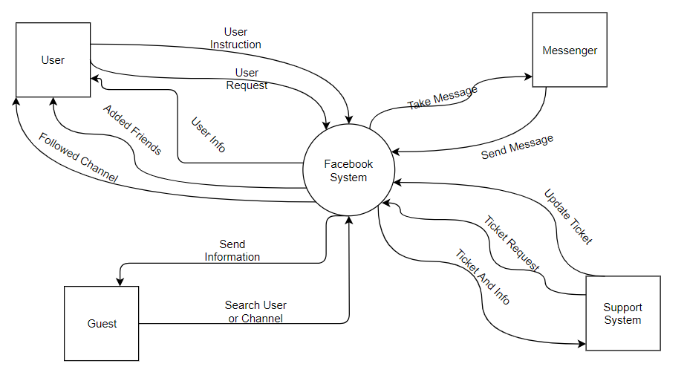

### Use Case Diagram

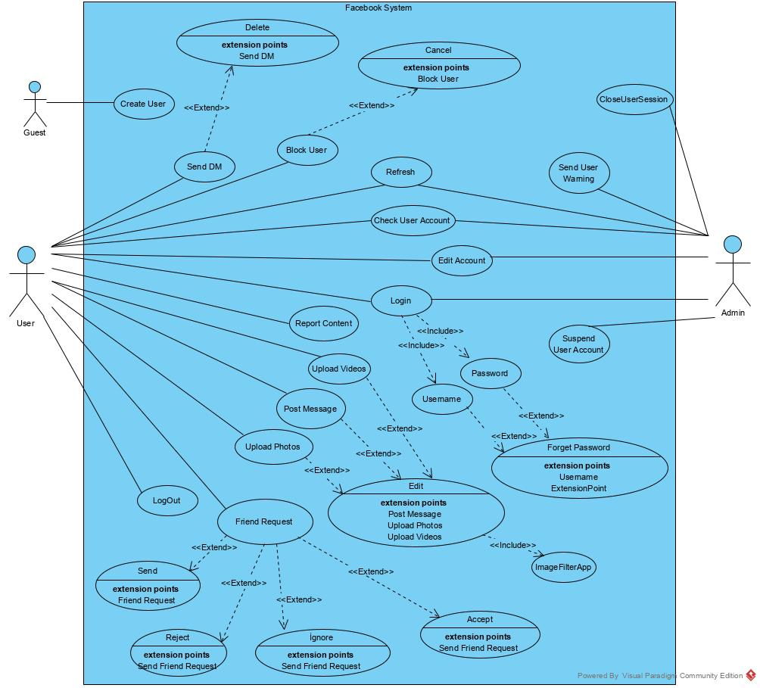

### Activity Diagram for Three Use Cases

### 3.1 Facebook Login Activity Diagram

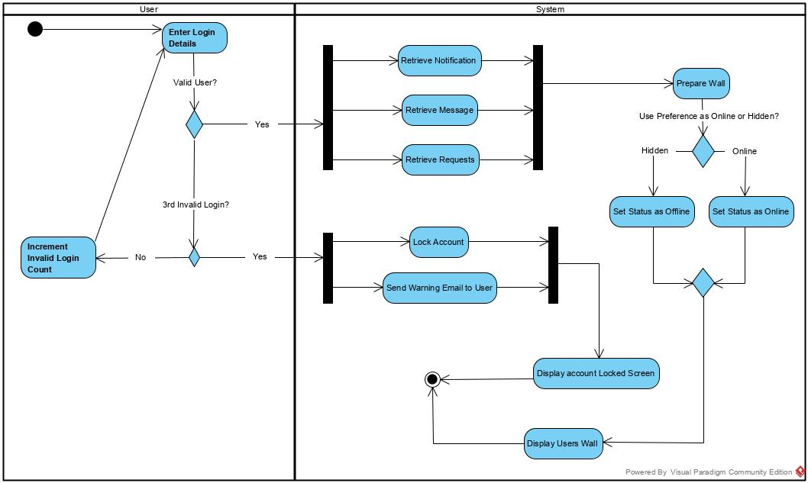

### 3.2 Facebook Create User Activity Diagram

### C:\Users\Mehmet Taha USTA\Desktop\dersler\4. Sınıf 2. dönem\BBM382\UML assignment\3-Activity diagram for three use cases\Activity Diagram2.jpg

### 3.3 Facebook Upload Photos or Videos Activity Diagram

### C:\Users\Mehmet Taha USTA\Desktop\dersler\4. Sınıf 2. dönem\BBM382\UML assignment\3-Activity diagram for three use cases\Activity Diagram3.jpg

### Class diagram

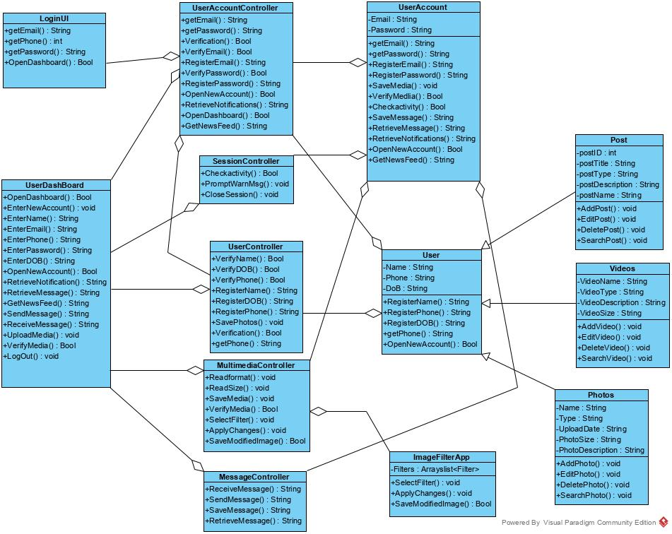

### Sequence Diagram for Three Use Cases

### 5.1 Create User Sequence Diagram

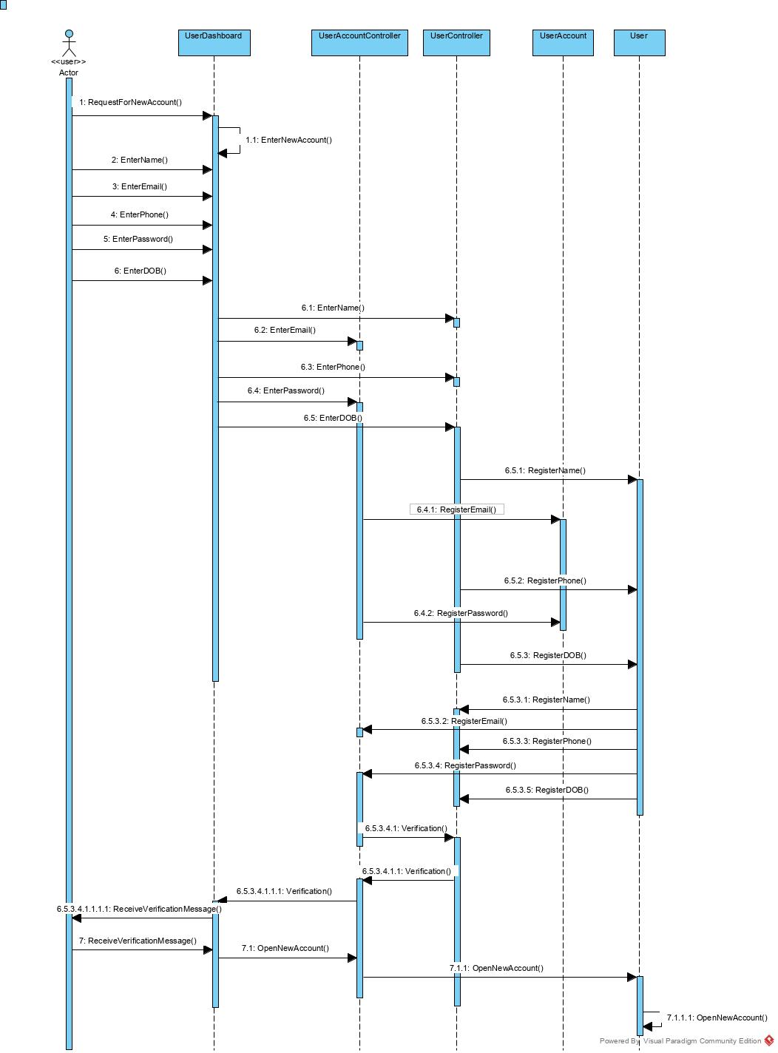

### 5.2 Upload Photos or Videos Sequence Diagram

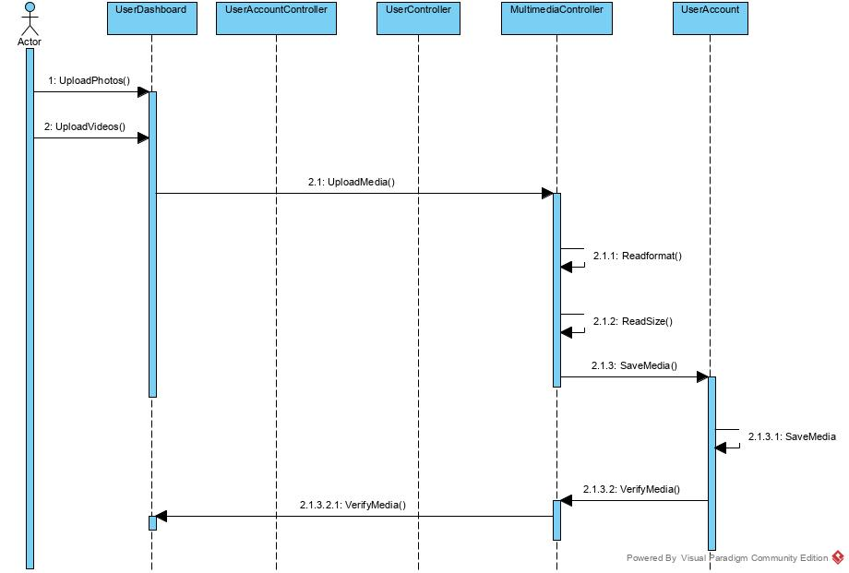

### 5.3 LogOut Sequence Diagram

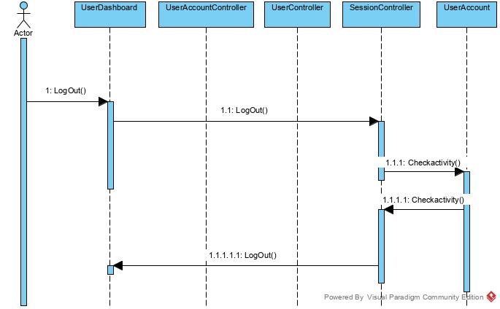

### Statemachine Diagram for Two Class Objects

### 6.1 Login and Create User Statemachine Diagram

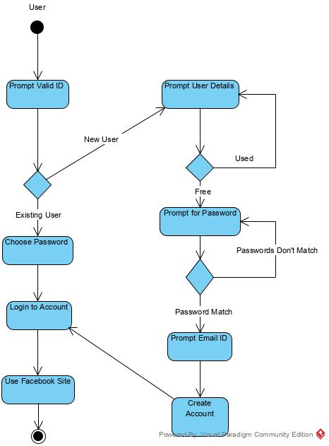

### 6.2 Login and Create User Statemachine Diagram

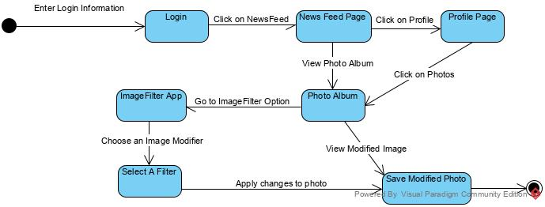

### Package Diagram

### C:\Users\Mehmet Taha USTA\Desktop\dersler\4. Sınıf 2. dönem\BBM382\UML assignment\7-Package diagram for your software architecture\Package Diagram1.jpg